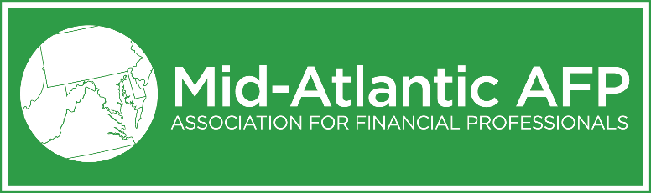
PROXY BALLOT
2019-2020 Mid Atlantic Association for Financial Professionals
ANNUAL MEETING
I hereby appoint MAAFP Board Secretary, Katie Kirkpatrick, with the power of substitution, my proxy, to attend and vote on my behalf, at the Mid Atlantic Association for Financial Professionals Annual Meeting to be held May 22, 2019, 5:30 PM at Guinness Open Gate Brewery & Barrel House , or at any adjournment thereof, on matters indicated below, and on any such matters that may come before the meeting. If a quorum is not achieved at that meeting, this proxy may be used for another vote until a quorum is achieved.
- ELECTION OF OFFICERS AND DIRECTORS for 2019-2020
To vote for all nominees listed below, please place an “X” in the box on the line that reads, “For all Nominees as Listed Below.” To vote for individual nominees or to nominate yourself or another candidate, complete the field below and place an “X” in the box to the left of the name of your preferred candidate. Please sign and date the ballot before scanning and submitting it to MAAFP@MAAFP.org.
- For All Nominees as Listed Below
OR vote for individual Candidates:
Officers
- Kaliopi Provencher, Owner, Treasury Consultant, Kaliopi Consulting
- Michelle Vanschoorisse, Director, Head of International Treasury, Legg Mason – Vice President
- Diane Mann, Treasury Project Manager, Johns Hopkins Medicine – Treasurer
- Katie Kirkpatrick, Director, Sales Growth Consulting – Secretary
Members at Large
- Jerri Thomas, SNAP Integrity Officer/Trainer, Maryland Department of Human Services – Past President
- Jane Padgett, Treasury Management Regional Sales Manager, M&T Bank – Past President
- Jennifer Erickson, Vice President, Treasury Management Consultant, Capital One
- Kevin Stever, FP&A, Finance Manager, Wells Fargo
- Write-In Candidate: __________________________________________ Position: ________________________

_________________________________________ _________________________________ ________________________
Signature Printed Name Date
Please sign, scan and return your ballot electronically to MAAFP@MAAFP.org by Wednesday, May 15, otherwise, please bring your ballot in person to the Annual Meeting on May 22, 2019.

